MACH4METAL

Metalworking machinery
Transito 21,
6909 DA BABBERICH
Netherlands
Tel. +31 (0)316 – 247123
Fax. +31 (0)316 - 247956
info@mach4metal.com
www.mach4metal.com

Account No: 66.52.13.883
IBAN : NL33 INGB 0665 2138 83
BIC : INGBNL2A

MAZAK VARIAXIS 500 – 5X
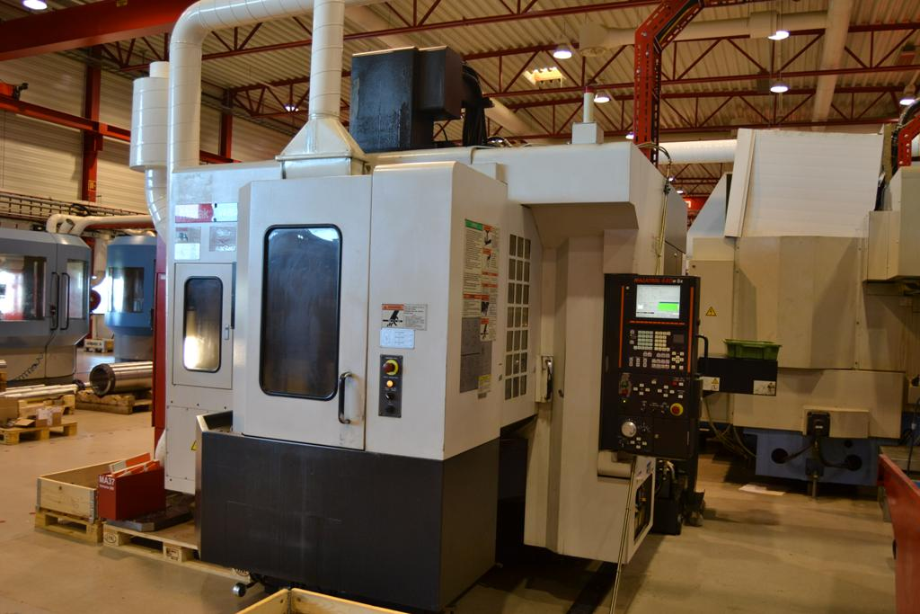
- Make : MAZAK
- Typ : VARIAXIS 500 – 5X
- No : 549175005
- Age : 2005

- X Travel : 510
- Y Travel : 510
- Z Travel : 460
- A Axis : - 120 + 30
- C Axis : - 360

- Table length : 500 °
- Table width : 400
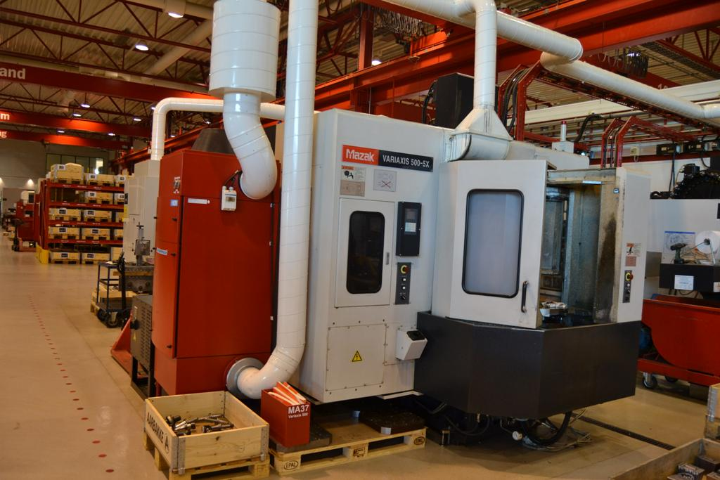
- Load on table : 300 Kg ?

- Spindle : Bt 40
- Speeds : 12.000 Rpm
- Power : 22 kW

- Minimum spindle – table : 190
- Maximum spindle – table : 460

- Rapid feed: X / Y /Z : 50.00 mm/M
- Rapid feed A Axis : 3600° M
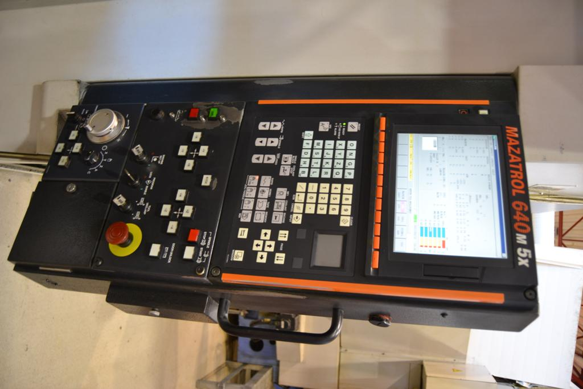
- Rapid feed C Axis : 7200° M

- ATC 30 Positions
- CNC MAZATROL 640 M 5X
- Chip conveyor
- High pressure coolant
- Some tooling package

- Dimensions: 4,0 x 3,2 x 2,85 Mtr.

Please Note: The above information has been obtained to the best of our ability and belief from, and from the manufacturers where possible. It is given in good faith, but its accuracy can not be guaranteed. Accordingly, it will not form a representation or constitute contractual terms. We advise you to check any vital details!
